Running and Testing Multiple Models + Suggestions Using LLMs:

[BMS_Datathon_Dataverse.ipynb](https://colab.research.google.com/drive/1VJQvBecN3yvYVwHwjT6RQgzDTSmRrB_5?usp=sharing)

Correlation Between the Data Points:

[Analysis Correlation.ipynb](https://colab.research.google.com/drive/1PgHLeZrCgpRNtjnYZdutRe8Z3VU8Bngi?usp=sharing)

Further Testing By Dropping Some Parameters like floor area which has lower weightage:

[Dataverse](https://colab.research.google.com/drive/1Y_oaiUedr-ctRLHM5kWOxRIFOwJ2R6yk?usp=sharing)

Team Members-

Gnanendra Naidu N

Aditya Ranjan

Conclusion:

Correlation Between the Parameters:

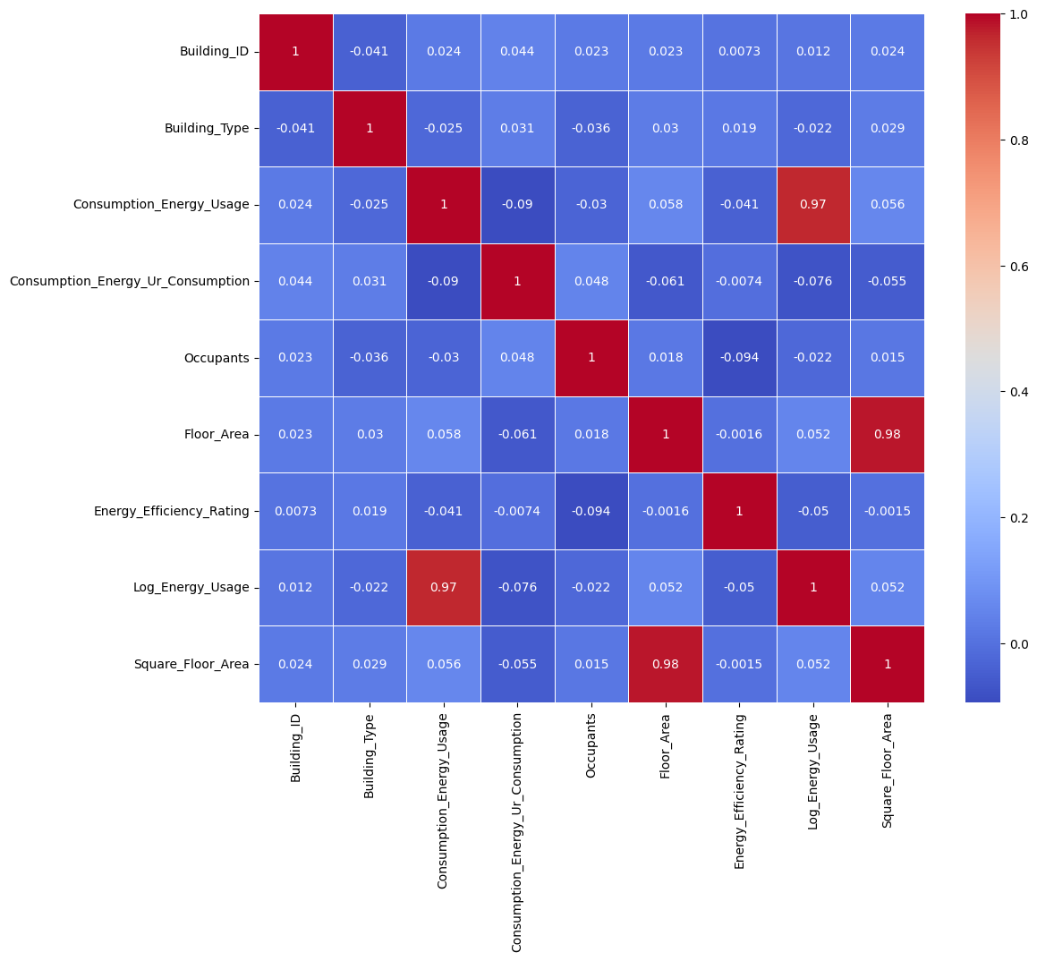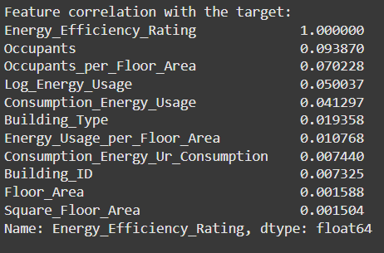

Best Result Models:

1.K-Nearest Neighbors

2.Linear Discriminant Analysis

3.Ridge Classifier

4.XGBoost

Suggestion Models:

1.Qwen 32B

2.GPT 4-o